1st October 2018

**WTCR Back in action in China**

After a 2 month break, the FIA World Touring Car Cup (WTCR) with YOKOHAMA as exclusive tyre supplier returned to excite the crowds, this time in China’s Ningbo circuit. With all races in Europe now completed, the Asian races will decide the Champion for 2018.

The 2017 FIA World Touring Car Champion Thed Björk was in sublime form with victories in Race 1 and 3, while team-mate and team boss Yvan Muller bagged the spoils in Race 2 for the Hyundai-powered YMR squad.

After finishing fourth in Race 1, early contact in Race 2 left Gabriele Tarquini on the sidelines. However, the BRC Racing Team Hyundai driver bounced back to finish second to Björk in Race 3 to ensure the Championship lead will still be his when action resumes in Wuhan – the epicentre of car manufacturing in China – at the weekend (5th -7th October). The street racing festival will mark the completion of Golden Week in the country, the world’s largest car market with 12 million sales in the first six months of 2018.

Tarquini’s cause, meanwhile, was aided when Muller retired from Race 3 with suspension damage and a puncture following contact. The Italian is nine points ahead of the Frenchman and eight up on Björk, who climbs from sixth to second in the table.

Esteban Guerrieri was a double podium visitor for ALL-INKL.COM Münnich Motorsport after two strong displays. However, the Argentine was denied a third top-three when contact with Norbert Michelisz early in the third race of the weekend forced him to retire his Honda Civic Type R TCR.

Mehdi Bennani signalled his return to form following his huge crash at WTCR Race of Portugal in June with second place in the reverse-grid Race 2, the Moroccan giving his all to remain on terms with Yvan Muller aboard his Sébastien Loeb Racing Volkswagen Golf GTI TCR.

Current Driver Standings;

1. Gabrielle Targuini 241
2. Thed Björk 233
3. Yvan Muller 232
4. Norbert Michelisz 195
5. Yann Ehrlacher 178

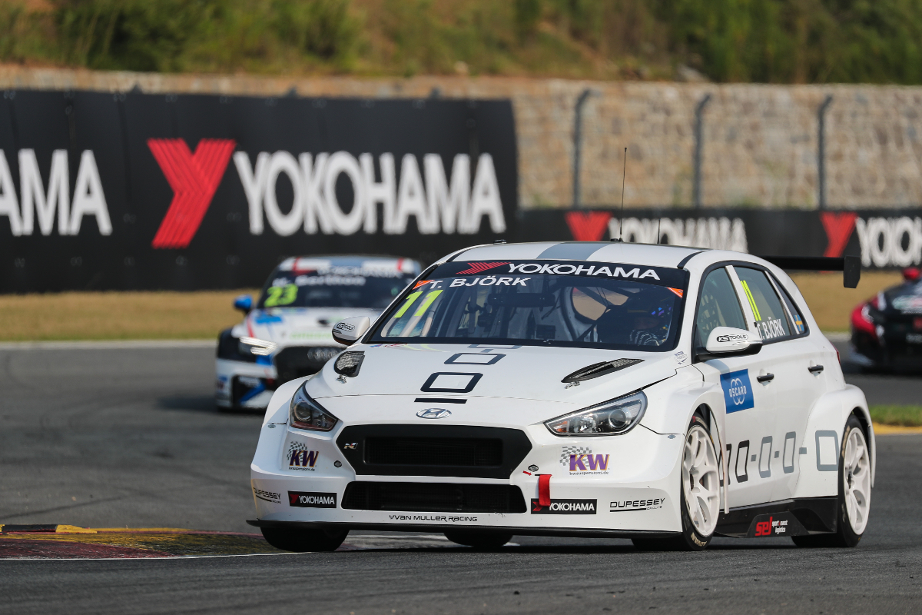

*Great racing from Thed Bjork photo Marc de Mattia*

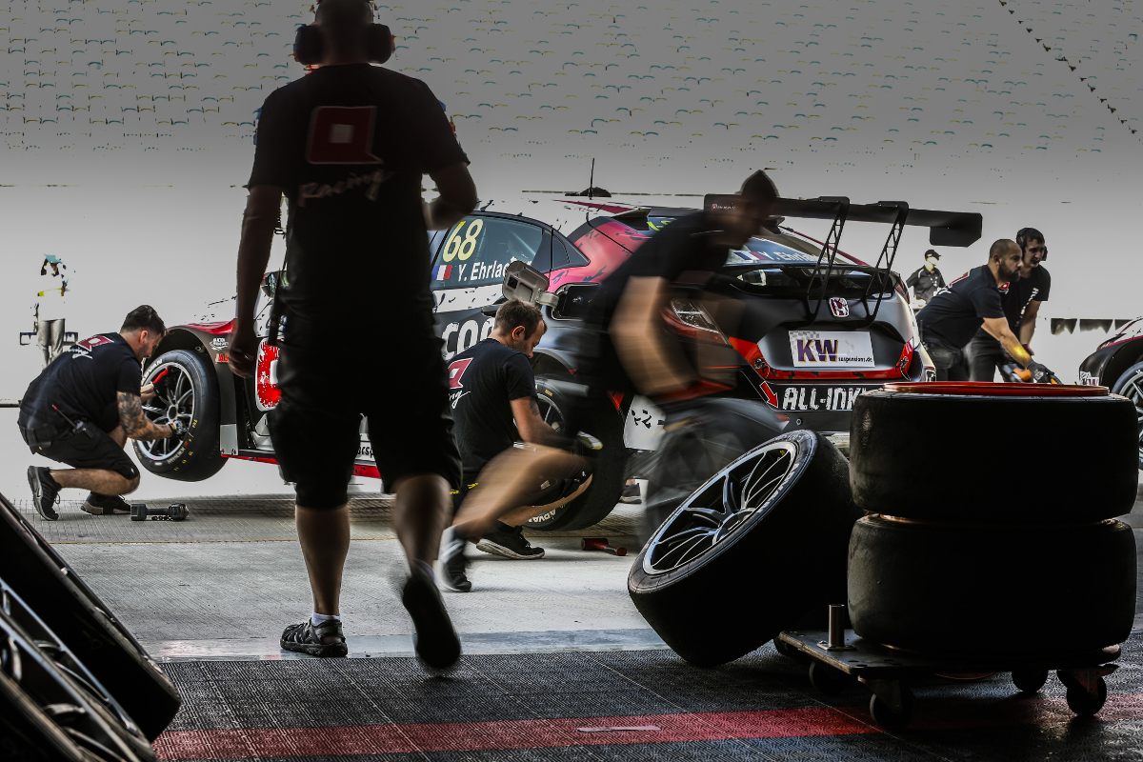

*Team Erlacher photo Jean Michel Le Meur*

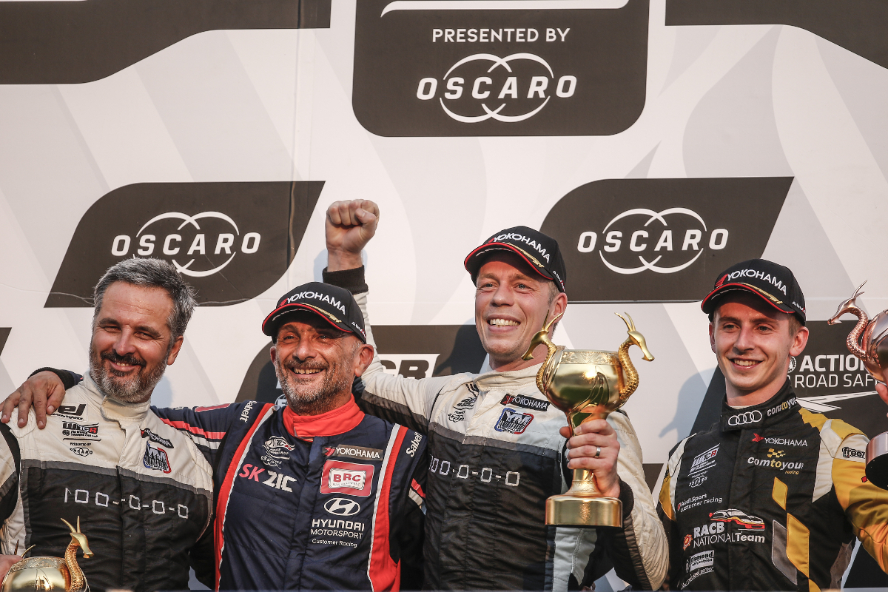

*Podium smiles photo Jean Michel Le Meur*